AWS DevOps CI/CD PROJECT
Project Title: CI/CD Pipeline Deployment Using AWS CodePipeline, CodeBuild and CodeDeploy
BY
ANGEL

STEP 1
GIT REPOSITORY
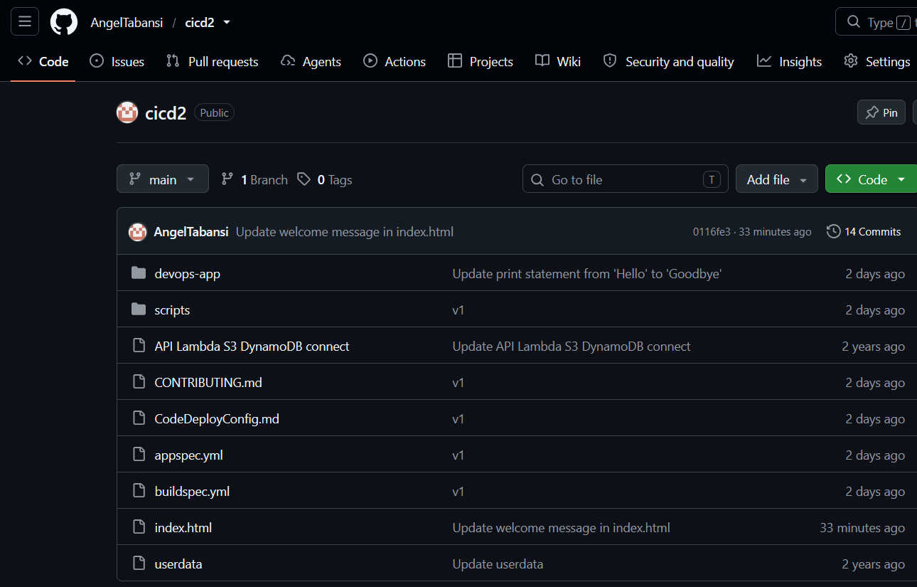

STEP 2
EC2 INSTANCE
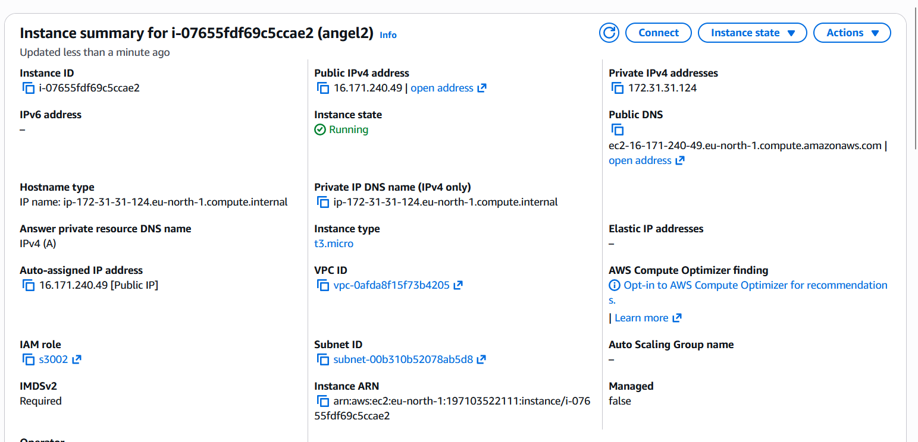

STEP 3:
SECURITY GROUP
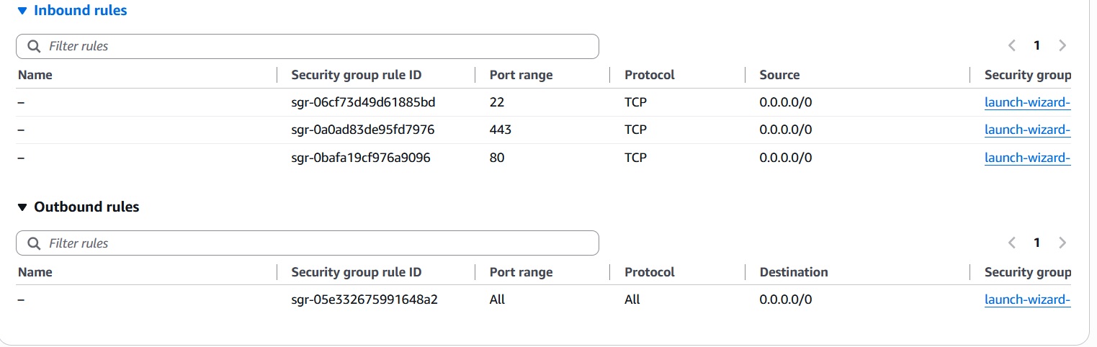

STEP 4:
CODEDEPLOY
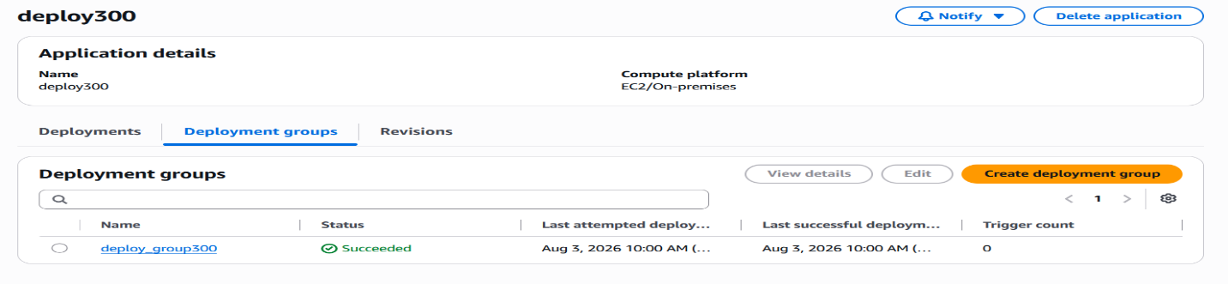
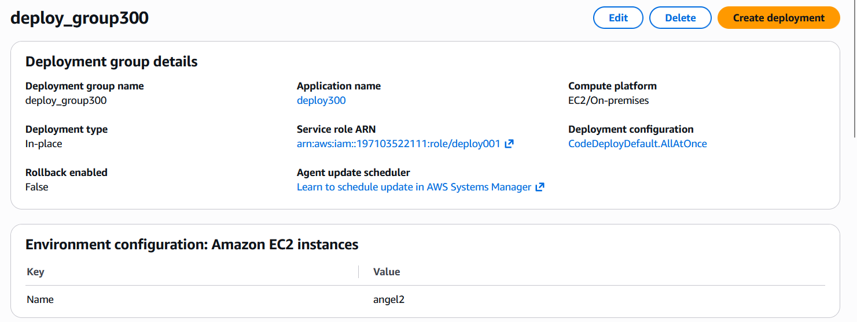

STEP 5:
CODEBUILD
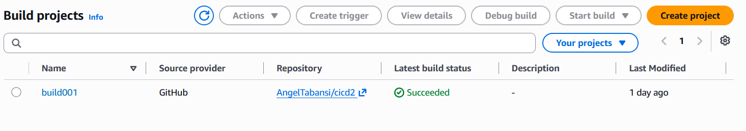
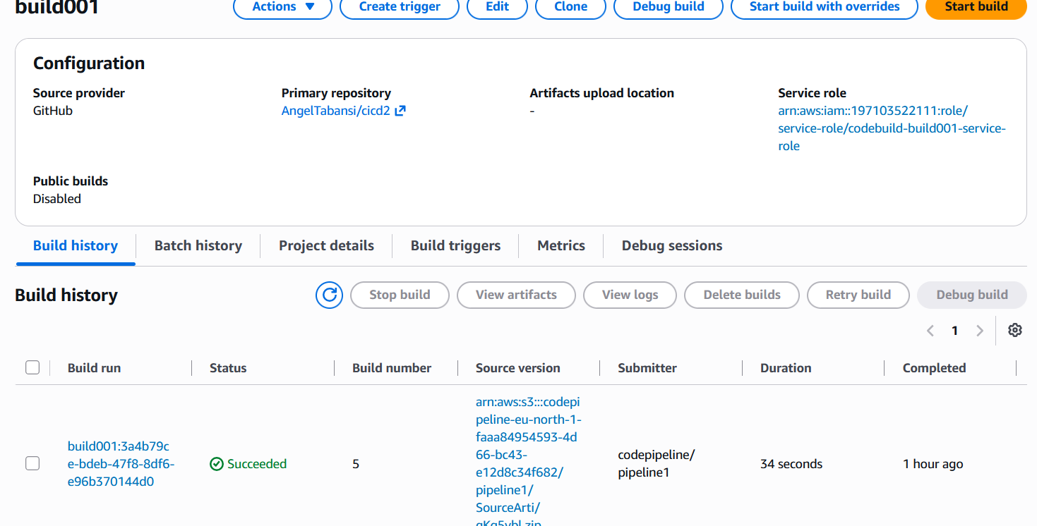
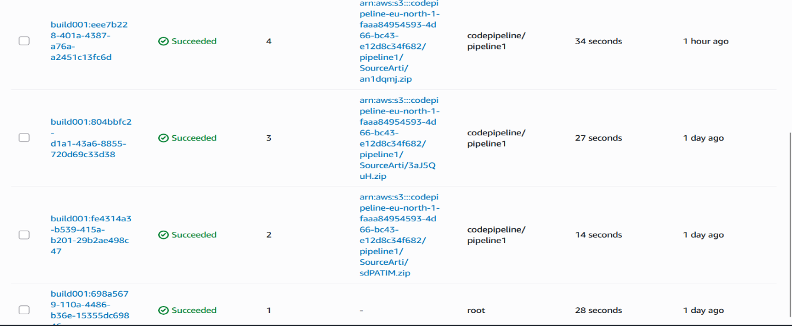

STEP 6:
CODEPIPELINE / DEPLOYMENT SUCCESS
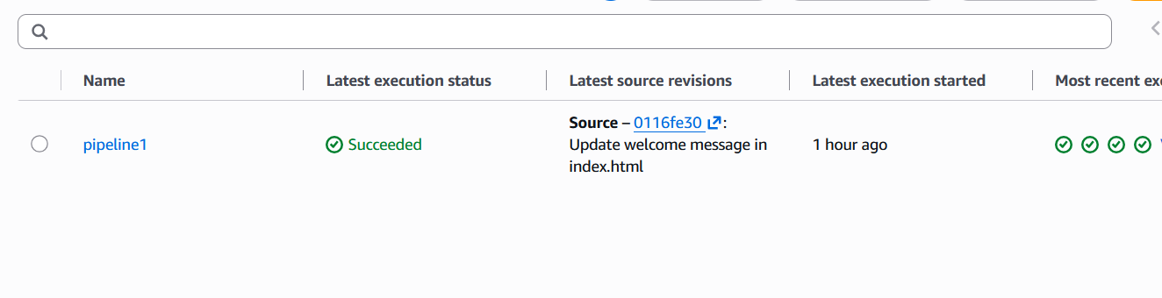
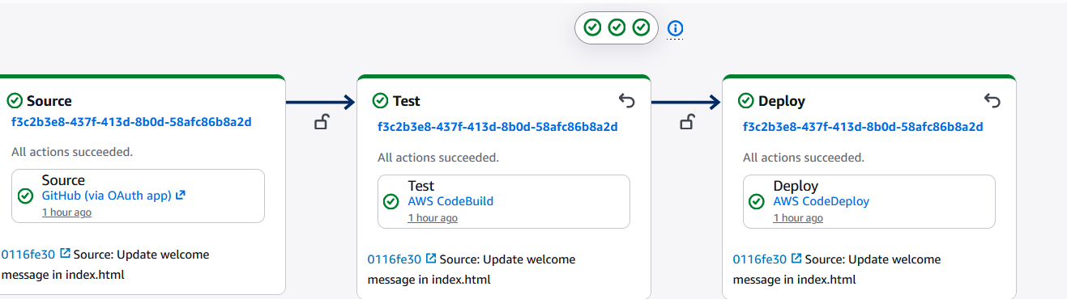
FINALLY, BROWSER SHOWING
